PRACTICAL NO:06
Working with Projections and WMS Data

Step 1: Open qgis->select project->new project
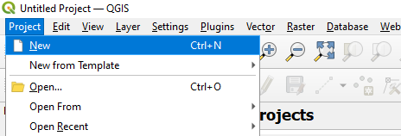
Step 2: layer->Add layer->Add Vector Layer
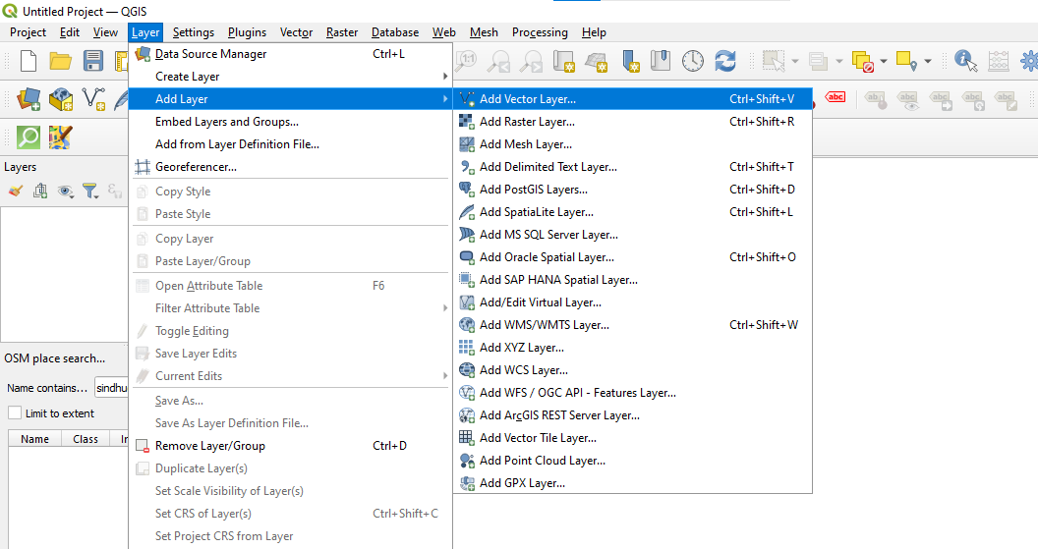
Step 3: select vector dataset->ne_10m_admin0_countries.zip->add
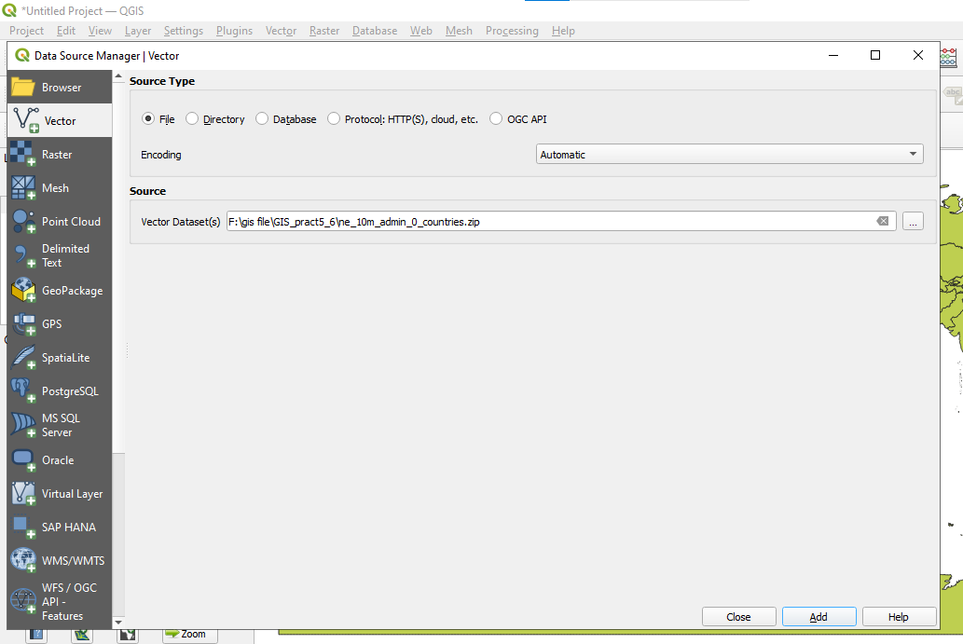

Output:
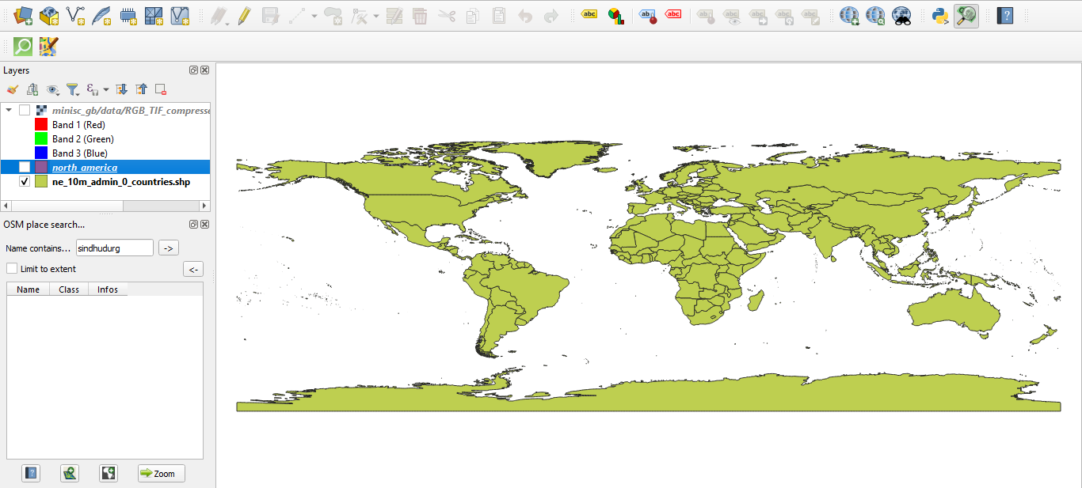
Step 4: right click on layer->layer CRS->set layer CRS
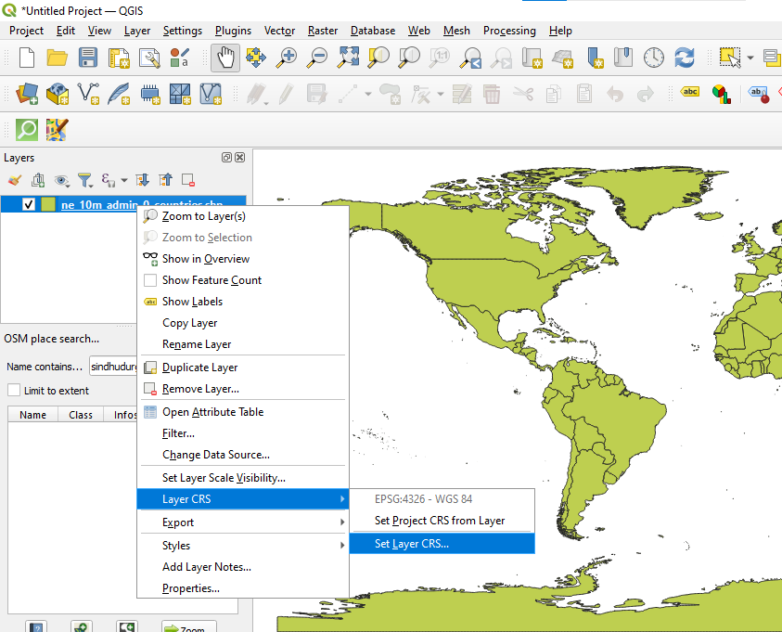

Step 5: select North_America_Albers_Equal_Area_conic(ESRI:102008)->ok
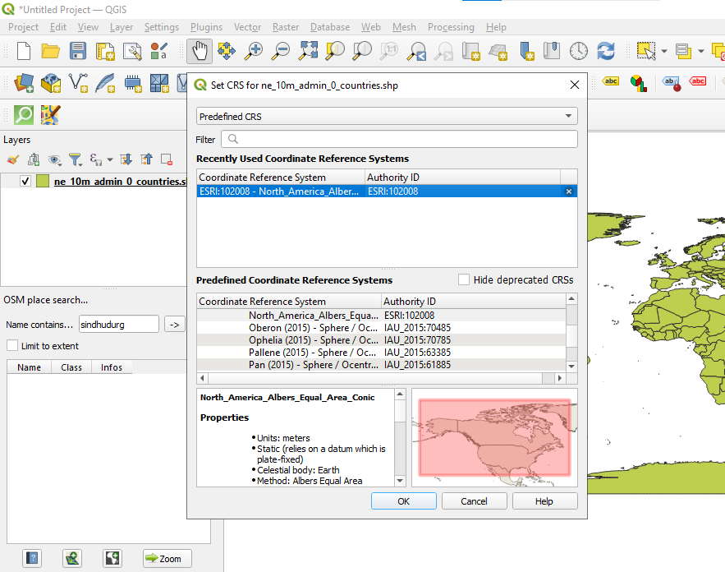
Output:
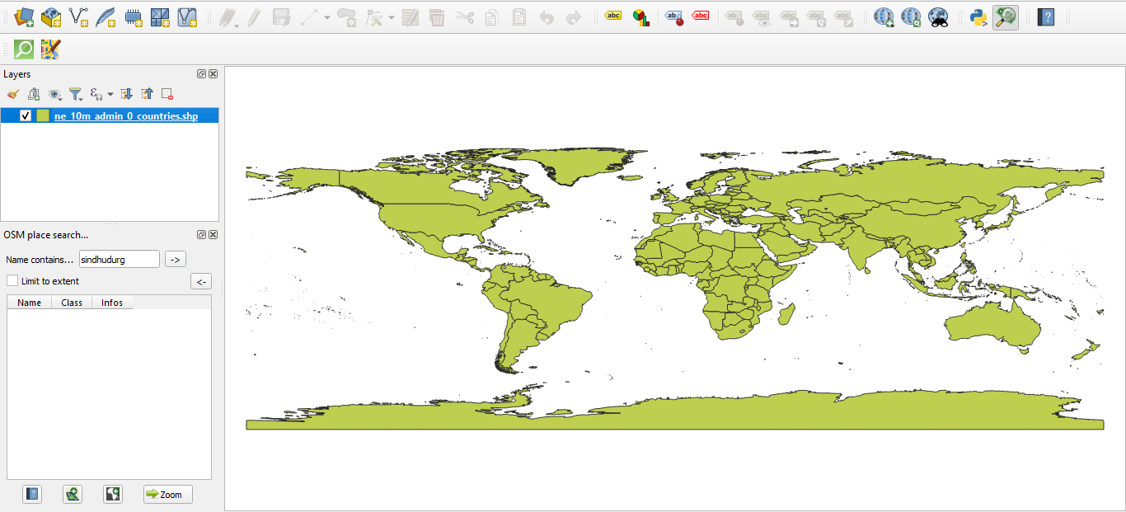
Step 6: Layer->save as
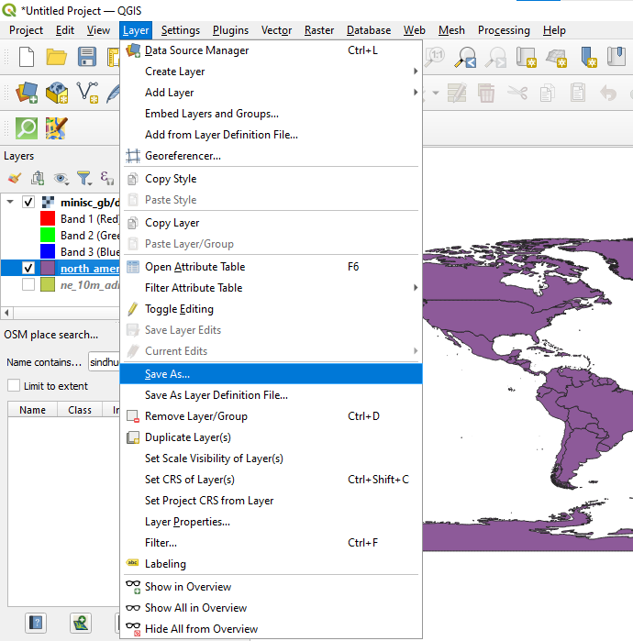
Step 7: Format (ESRI Shapefile)->file name->ok
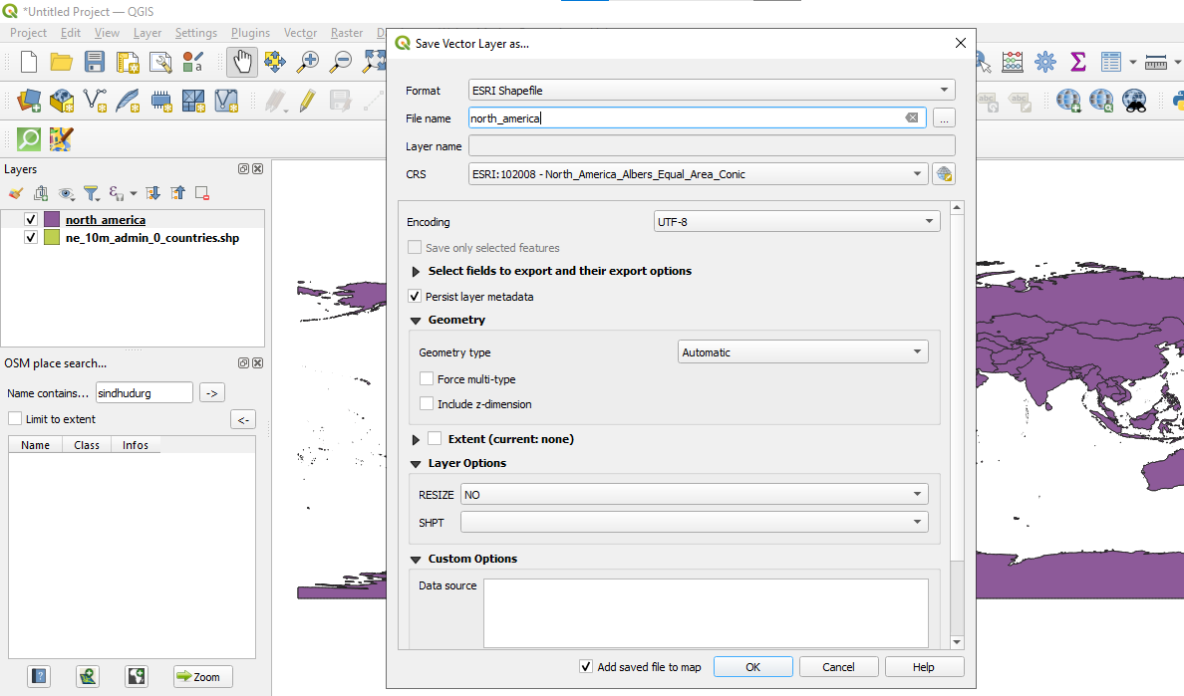
Output:
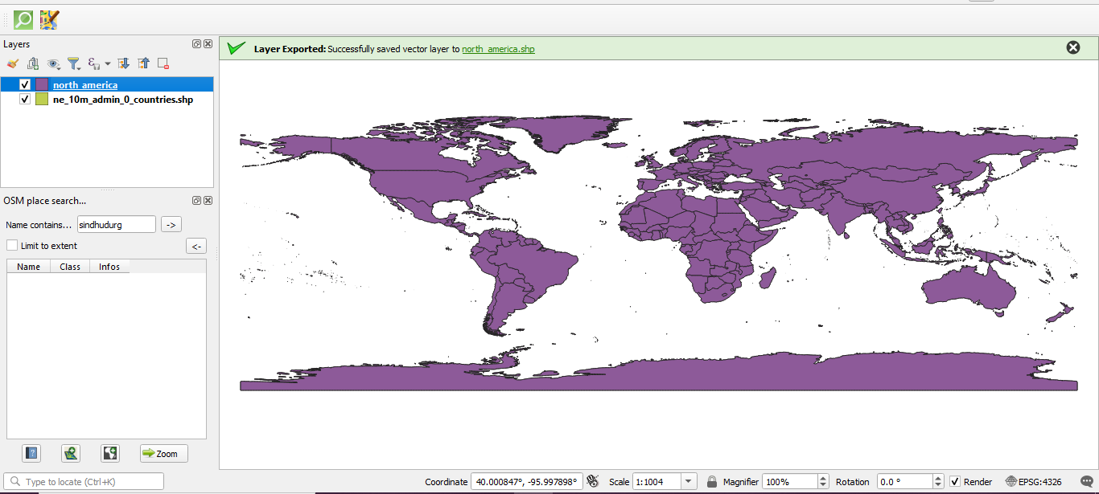
Step 8: Layer->Add layer->Add Raster Layer
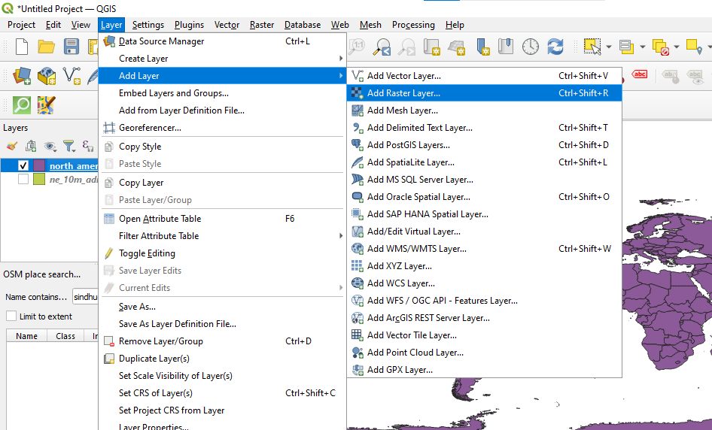

Step 9: Raster Dataset->minisc_gb.zip->add
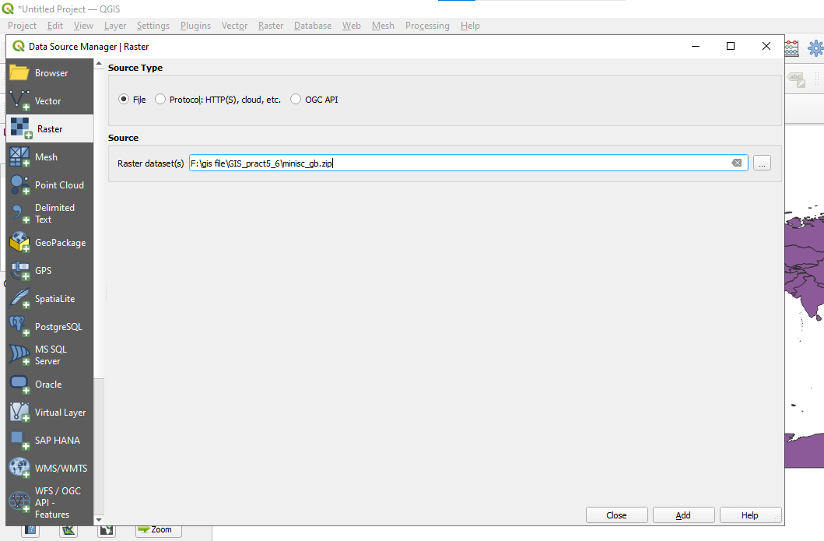
Output:
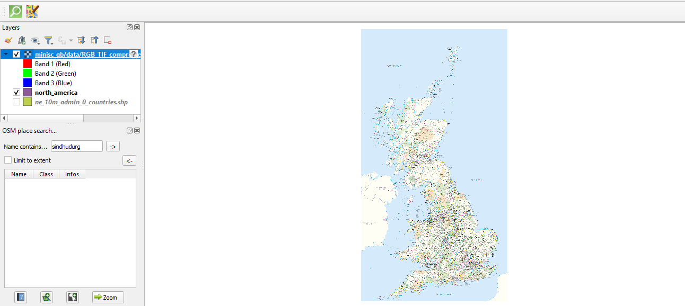
Step 10: Right click on layer->Layer CRS->Set Layer CRS
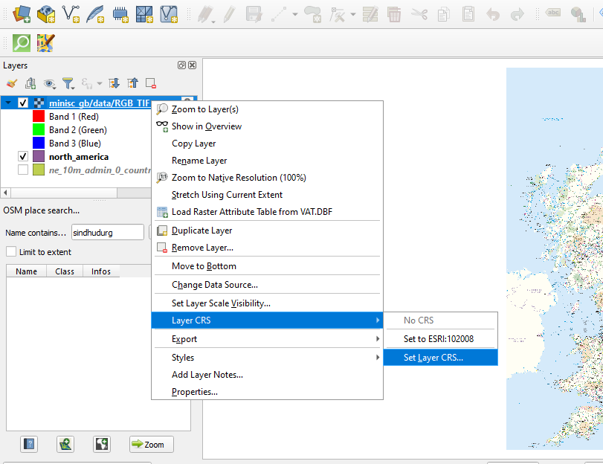

Step 11: select British National Grid(ESRI:27700)->ok
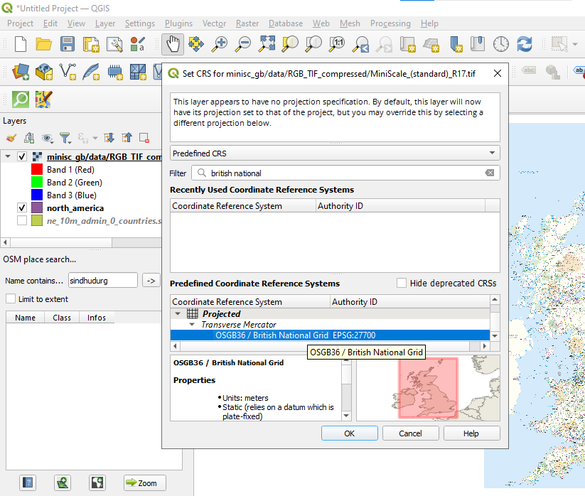
Output:
